EXP 8
Consider a Online College Notice Portal. Develop a JavaScript program that will validate the controls in the forms you have created for the
application. State the assumptions you make (business logic you are taking into consideration). Note: Your application must access a database using Servlet/JSP.

AIM:
To develop an Online College Notice Portal that validates user inputs using JavaScript on the client side and accesses a database using Servlet/JSP for storing and processing registration details.

ALGORITHM:
- Start the application.
- Display the registration form to the user.
- Accept user inputs such as name, email, password, phone number, and exam details.
- Perform client-side validation using JavaScript:
  - Check for empty fields.
  - Validate email format.
  - Validate password strength.
  - Validate phone number length and format.
- If validation fails:
  - Display appropriate error messages.
  - Prevent form submission.
- If validation is successful:
  - Submit the form to the server (Servlet/JSP).
- On the server side:
  - Receive the form data.
  - Perform server-side validation.
  - Connect to the database.
- Store user details in the database.
- Generate confirmation message for successful registration.
- Stop the application.

STEPS:
- Design the registration form with fields like name, email, password, phone number, exam selection, and date.
- Implement JavaScript validation for all form controls.
- Ensure proper error messages are displayed for invalid inputs.
- Configure Servlet/JSP to handle form submission.
- Establish database connectivity using JDBC.
- Create a database table for storing registration details.
- Insert validated data into the database.
- Retrieve and display confirmation details to the user.
- Handle duplicate registrations and invalid data cases.
- Test the application for different input scenarios.

ASSUMPTIONS (BUSINESS LOGIC)
- Each user must register with a unique email ID.
- Password must meet minimum security requirements (e.g., length, characters).
- Phone number must be exactly 10 digits.
- All fields are mandatory.
- A user can register for only one exam at a time.
- Exam date must be a valid future date.
- Database stores all user and exam details securely.
- Server-side validation is mandatory even after client-side validation.
- Duplicate registrations are not allowed.
- Proper error handling and user feedback are provided.

Program:

AddNoticeServlet.java:

import java.io.*; import javax.servlet.*;

import javax.servlet.http.*;
import javax.servlet.annotation.WebServlet; import java.sql.*;

@WebServlet("/AddLibraryServlet")
public class AddLibraryServlet extends HttpServlet {

protected void doPost(HttpServletRequest request, HttpServletResponse response) throws ServletException, IOException {

String title = request.getParameter("title");
String description = request.getParameter("description"); String date = request.getParameter("date");
String department = request.getParameter("department");

response.setContentType("text/html");

try {
// Load Driver
Class.forName("com.mysql.cj.jdbc.Driver");

// Connect to DB
Connection con = DriverManager.getConnection( "jdbc:mysql://localhost:3306/library_system", "root", "root"
);

// Insert Query
PreparedStatement ps = con.prepareStatement(
"INSERT INTO notices(title, date, department) VALUES (?, ?, ?)"
);

ps.setString(1, title);

ps.setString(2, date); ps.setString(3, department);

int i = ps.executeUpdate();

if (i > 0) {
// Success → redirect response.sendRedirect("viewLibrary.jsp");
} else {
response.getWriter().println("Insert failed");
}
ps.close();
con.close();

} catch (Exception e) { e.printStackTrace();
response.getWriter().println("Error: " + e.getMessage());
}
}
}

OUTPUT:

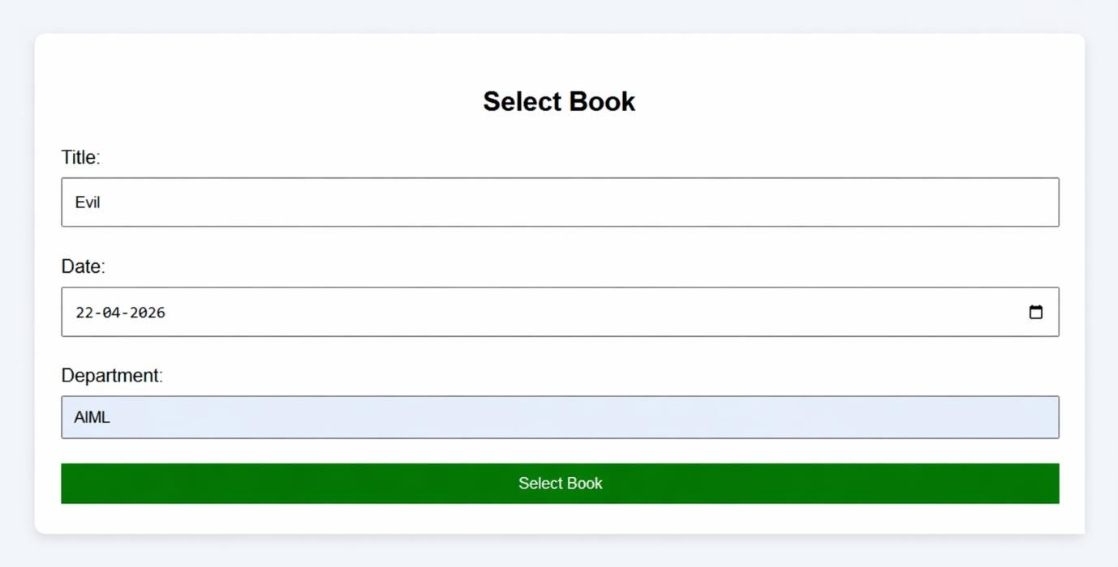

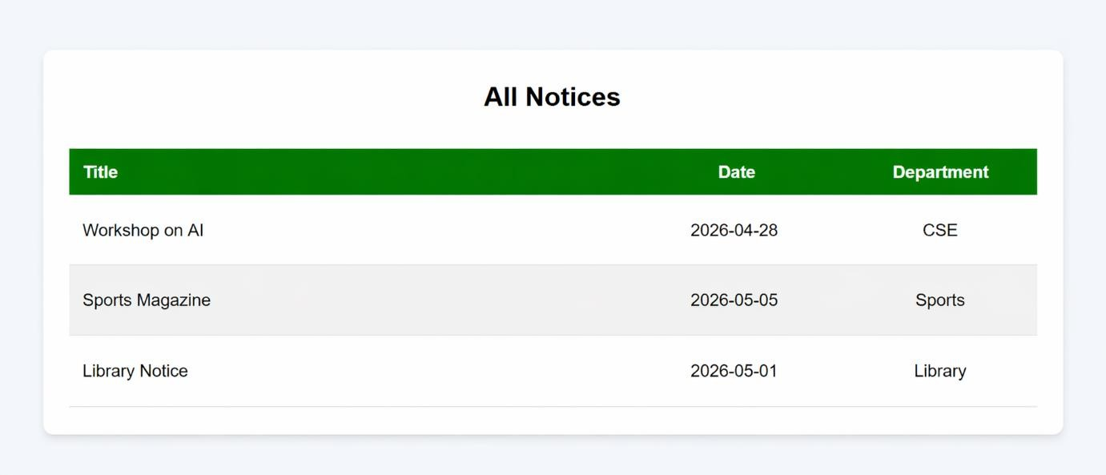

RESULT
The Online Exam Registration Portal successfully validates user inputs using JavaScript and stores the validated data in a database using Servlet/JSP, ensuring accurate and secure registration.

